

IoT Projesi: Akıllı saat

b141210120 – Aida Tahirbegovic

b141210103 – Ahmed Berberovic

Proje Şeması

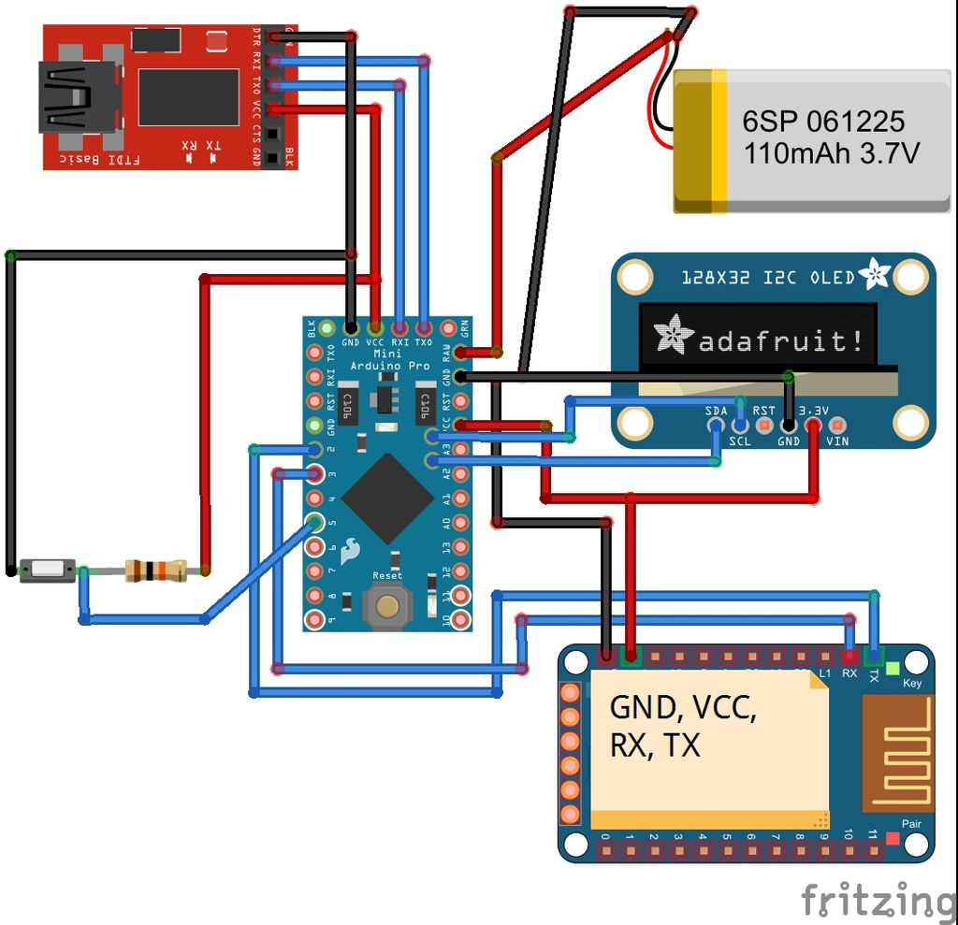

**Bağlantılar**

**# Bluetooth-> Arduino :**

VCC -> 3.3V

GND -> GND

TX -> D2

RX -> D3

**# OLED -> Arduino :**

GND -> GND

VCC -> VCC

SDA -> 9(the analog 4th pin)

SCL -> A5(the analog 5th pin),

SCL ->10

RST->13

DC->11;

**# USB to UART module -> Arduino :**

3.3V -> VCC

TXD -> RXD

RXD -> TXD

GND -> GND

